**Public speaking information Zoé Meckbach**

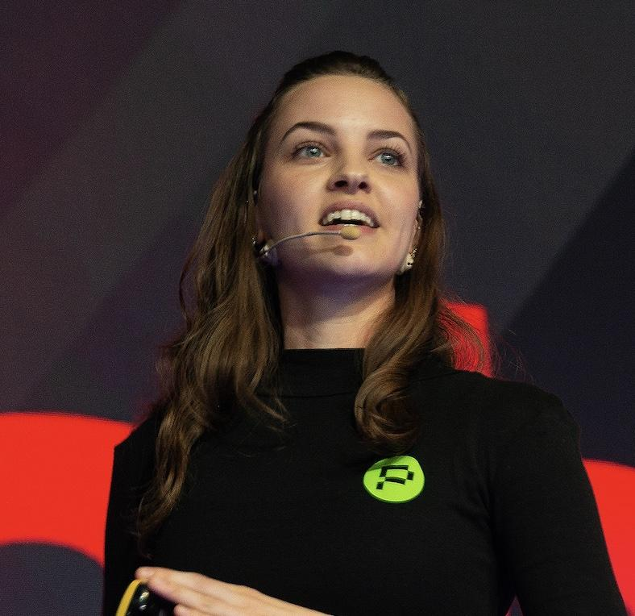

**VP of Growth & Partner at Phala Network, Council Member**

**Polkadot global head ambassador**

Twitter: @zoemcfox

Linkedin:<https://www.linkedin.com/in/zora-meckbach/>

Zoé is VP and Partner at Phala Network and leads European growth and business development for the protocol.

She is also the global head Ambassador of events for Polkadot as well as a curator for the on-chain events bounty and a council member for Phala.

Zoé has worked for several blockchain start-ups as well as big tech giants like Google in silicon valley. Currently based in Berlin, Zoé grows the brand for Phala Network and Polkadot in Europe.

With her background in information & cybersecurity and international business, Zoé’s passion is to break down complex concepts into simple to understand content to educate the masses.

Education: Zoé holds a B.A. in Chinese Society from Fudan University Shanghai, 2016, a B.A. in International Supply Chain Management from HIWL Bremen, 2017, and two master degrees: M.Sc. International Business from HULT Boston 2018, and M.Sc. Information & Cybersecurity from ITU Santa Clara, 2020.